Expt 6 Date: /09/2026
Kruskal’s Minimum Cost Spanning Tree.

Aim: Implement Kruskal’s Minimum Cost Spanning Tree.
Theory:
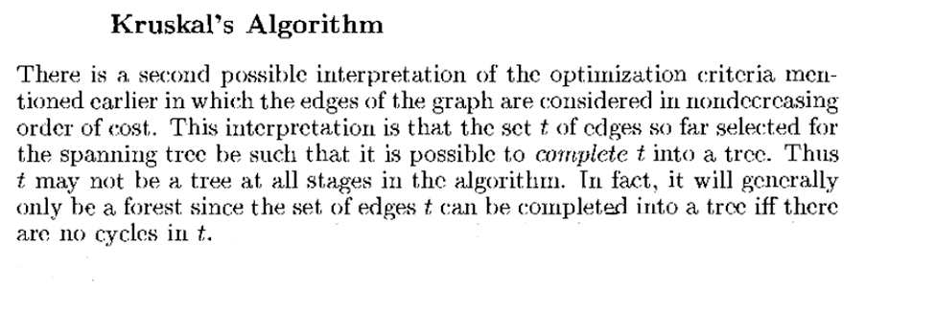
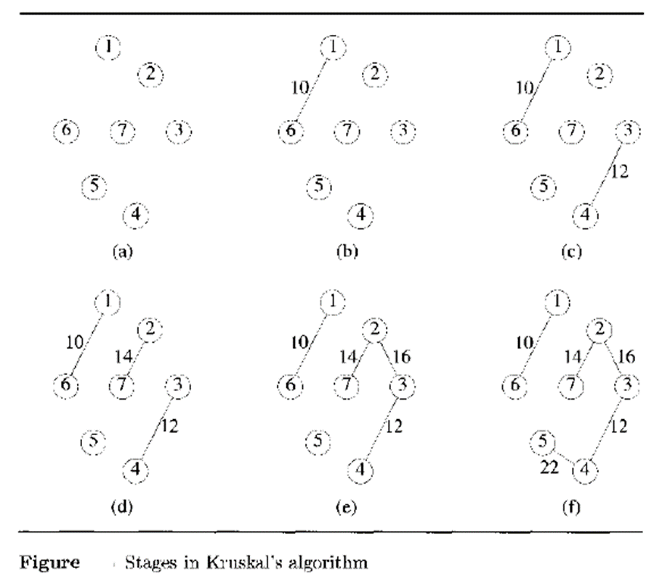
Algorithm:
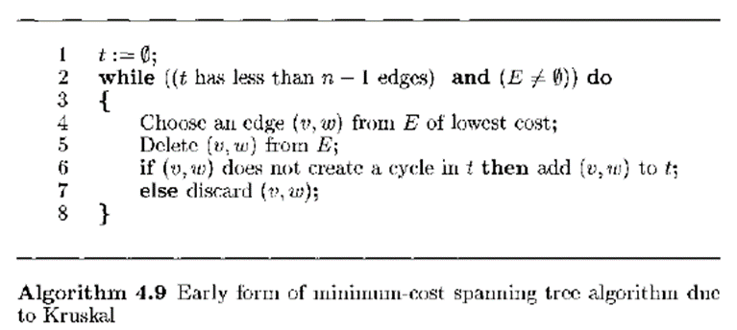

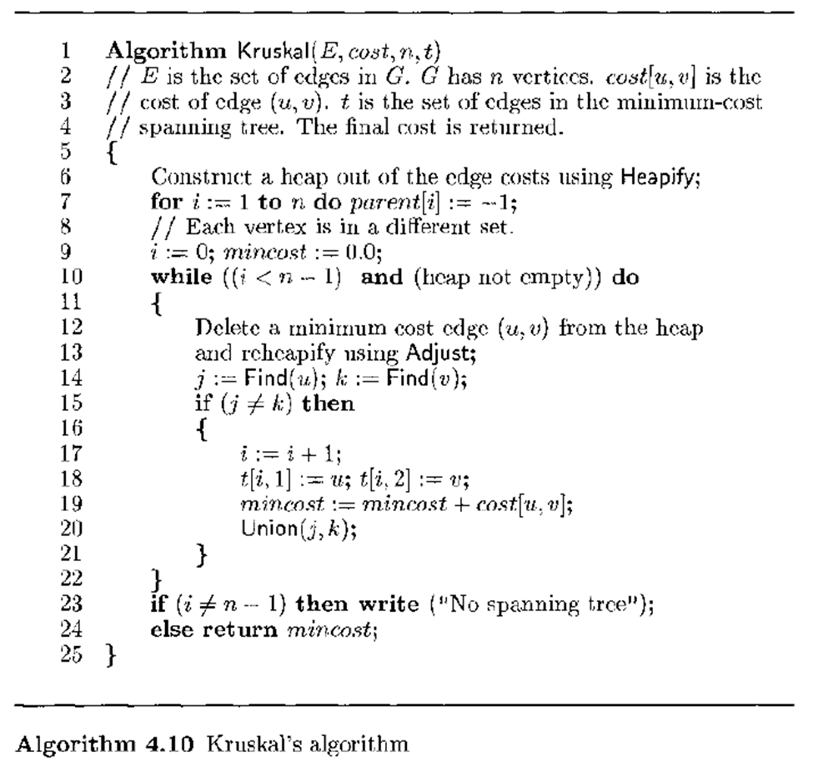
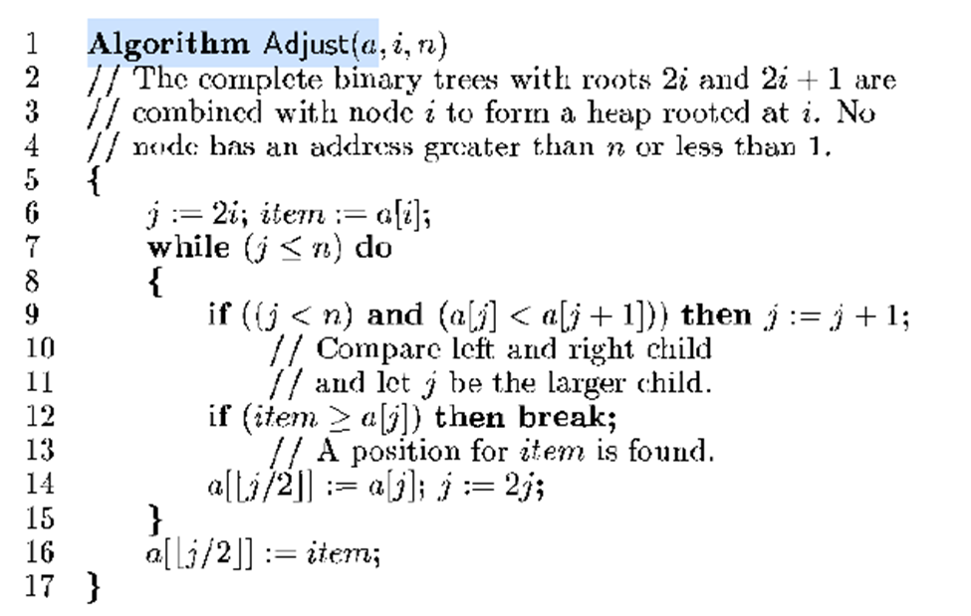
Note: the above algorithm is for a max heap.
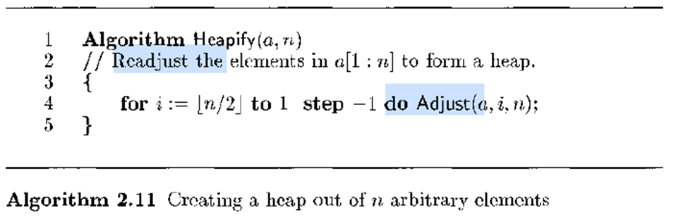

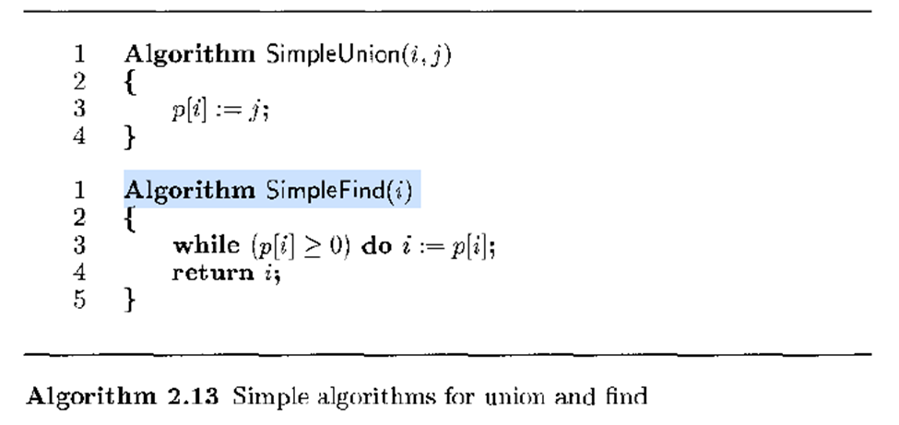
Kruskal’s algorithm for the graph[7][7], |V| = 7 Edge costs
struct edge edgeSet[10] = {
{ 0, 0, 0 },//0 dummy
{ 10, 1, 6 },//1; cost, edge (u, v)
{ 28, 1, 2 },//2
{ 14, 2, 7 },//3
{ 16, 2, 3 },//4
{ 25, 5, 6 },//5
{ 24, 5, 7 },//6
{ 18, 4, 7 },//7
{ 12, 3, 4 },//8
{ 22, 4, 5 },//9
};

Edge with the least cost in the heap
struct minEdge {
int cost;
int u;
int v;
};

MST
int t[V][3] = { 0, 0, 0};

Parent/Set
int parent[V];

Step 1: Construct a min-heap of the edge costs
void heapify()
{
for (int i = hsize / 2;i > 1;i--)
adjust(i, hsize);
}

void adjust(int i, int n)
{
int j = 2 * i;//position in the heap to check
int item = edgeSet[i].cost, u_item = edgeSet[i].u, v_item = edgeSet[i].v;//save the values at the postion

while (j <= n)
{//compare left and right child and let j be the smaller child
if ((j < n) && (edgeSet[j].cost > edgeSet[j + 1].cost))
j++;
if (item <= edgeSet[j].cost)
break;//a position for item has been found
edgeSet[j / 2].cost = edgeSet[j].cost;
edgeSet[j / 2].u = edgeSet[j].u;
edgeSet[j / 2].v = edgeSet[j].v;
j = 2 * j;
}

edgeSet[j / 2].cost = item;
edgeSet[j / 2].u = u_item;
edgeSet[j / 2].v = v_item;
}

Step 2: Each vertex is a different set
for (i = 1; i <= V; i++){
parent[i] = -1;
}

Step 3: initialize the count of MST edges, count of deleted edges
i = 0; delEdgeCount = 0;

Step 4: while the count of MST edges <n-1 and the heap is not empty

while ((i < V - 1) && (edgeSet[0].cost != -1))//heap not empty
{

minEdge e = { 0,0,0 }; //initialize the min edge
int NoOfEdges = hsize - delEdgeCount; // //no. of edges left in the heap
//delete a minimum cost edge (u, v) from the heap and reheapify using Adjust;
e = delMin(e, NoOfEdges);
//increment the no. of edges deleted
delEdgeCount = delEdgeCount + 1;
//Find(i): given the element i, find the set containing i
j = find(e.u);
k = find(e.v);
//if they are not in the same set, i.e. no cycle
if (j != k){
//add the edge to the MST
i = i + 1;
t[i][1] = e.u;
t[i][2] = e.v;
t[i][3] = e.cost;
//update min-cost
mincost = mincost + e.cost;
//set the parent field of one of the roots to the other root
Union(j, k);
}
}

Step 4: auxiliary functions
// delete a min cost edge (u, v) from the heap
minEdge delMin(minEdge e, int n)
{
if (n == 0)
{
cout << "Heap is empty";
e.cost = -1;
e.u = -1;
e.v = -1;
edgeSet[0].cost = -1;
return e;
}

e.cost = edgeSet[1].cost;
e.u = edgeSet[1].u;
e.v = edgeSet[1].v;

edgeSet[1].cost = edgeSet[n].cost;
edgeSet[1].u = edgeSet[n].u;
edgeSet[1].v = edgeSet[n].v;

adjust(1, n - 1);

return e;
}

//Follow the indices, starting at i until we reach a node with parent value -1.
//Once parent[i] is negative, we have reached the root
int find(int i)
{
while (parent[i] >= 0)
i = parent[i];
return i;
}

//Pass in two trees with roots i and j. The first tree becomes a subtree of the second
void Union(int i, int j)
{
parent[i] = j;
}

Task : Write programs to implement Kruskal’s algorithms.

Code:

Output:

Conclusion:

